Burbank High School

Syllabus

Teacher: Myranda Hess Subject: IB Math SL (Room 209)

Conference: 1st Period E-mail: mhess1@saisd.net

School Year: 2020-2021

Course Description

This course caters for students who already possess knowledge of basic mathematical concepts, and who are equipped with the skills needed to apply simple mathematical techniques correctly. The majority of these students will expect to need a sound mathematical background as they prepare for future studies in subjects such as chemistry, economics, psychology and business administration.

Course Goal
The course goal is that 100% of students pass and or exceed the IB Math Paper 1, Paper II, and IA with a 4, 5, 6, or 7, and are fully prepared for College Level Math.

Course Content

The following units are to be covered:

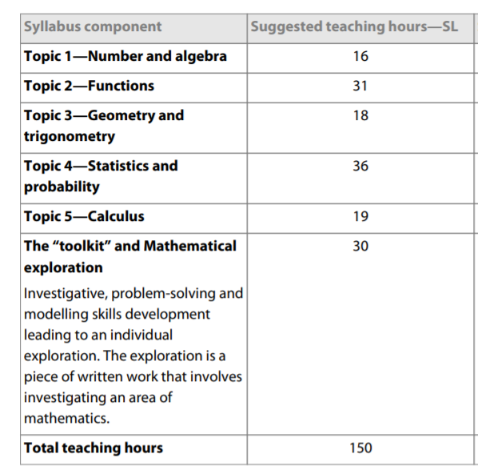

Grading Criteria

The student’s semester grade will be based on the following:

Type of Work | Category | Percentage (%)
CLASS WORK/ NOTES/ HOMEWORK/EXIT TICKET | I | 60%
UNIT EXAMS | II | 40%

Materials Needed Daily
- Pencils and Eraser
- Graphing calculator -- You may provide your own TI-Inspire or use a calculator from our class set. Class set calculators are not available for check-out.

Make-Up Work Policy for Absences
All assignments missed because of an excused absence will be made up by the end of the week of the student’s return to class. Assignment not made up will be graded as a zero. All missed quizzes and exams must be made up after school, and scheduled with the teacher beforehand.

Tutoring

Tutoring is available before school Monday through Friday.

By Appointment

I will let you know if I will not be available ahead of time.

